**Item**  **PP2024.01 – 192 Waterworks Road (Amendment to LEP – Zoning and Minimum Lot Size)**

**Author:** **Councils Town Planner**

**Attachment:** **Submitted Draft Planning Proposal, including supporting appendices.**

***RECOMMENDATION:***

***Council resolve to:***

* ***Provide in principle support the Draft Planning Proposal; and***
* ***Refer the Planning Proposal to the Department of Planning, Housing and Infrastructure for Gateway Determination; and,***
* ***Seek that Council be appointed the Local Plan-Making Authority by the Department***

SUMMARY

Council has received an application to amend the Junee Local Environmental Plan (LEP) 2012, through a draft Planning Proposal. The amendment requested is to Lot 1, Section 15, DP10919, known as 192 Waterworks Road, Junee, in which the applicant seeks to rezone the site from the current RU1 (Primary Production) to RU5 (Village) and R5 (Large Lot Residential) and seek a reduction in the current Minimum Lot Size from 100ha down to as low as 700sqm. The proposal also includes a preliminary subdivision layout with an expected yield of up to 300 residential allotments.

**BACKGROUND & ASSESSMENT**

Council staff have had several discussions with the applicant leading up to the formal submission of the draft planning proposal. These discussions help identify a number of considerations that were subsequently addressed through the provision of a Scoping Report provided by the applicant. This Scoping Report formed the basis of the planning proposal and enabled Council staff to provide further feedback, which has been incorporated into the submitted Draft Planning Proposal.

The Planning Proposal as submitted includes amendments to the Zoning and Minimum Lot Size mapping to Lot 1, Section 15, DP10919, known as 192 Waterworks Road (subject site). The subject site is approximately 78.2Ha in area, with a frontage of 646m to Waterworks Road, and is currently zoned RU1 (Primary Production), with a minimum lot size for subdivision of 100ha. The land is undulating with significant elevation changes and features across the site, but generally slopes up from Waterworks Road to a ridge in the southern portion of the site. A significant gully is also located in the southern portion of the property, which forms the upper catchment area for stormwater flowing down through the eastern part of Junee to the wetlands. The site is bound by an unformed road reserve along its western boundary, connecting Waterworks Road to Cedric and Pitt Streets.

The proposed zoning changes are shown in the figure below and would see the introduction of RU5 (Village) and R5 (Large Lot Residential) zones over the subject site. The proposed RU5 (Village) zone is focused towards the northern portion of the site, where there is more suitable terrain for urban style development, and where existing access from Waterworks Road is located. Where the topography of the site becomes more challenging over the southern portion of the site, less density is proposed through the application of a R5 (Large Lot Residential) zone. The current minimum lot size for subdivision of the site is currently 100ha, which, if the rezoning were to occur, would also need to be amended. It is proposed to introduce a range of minimum lot sizes over the subject site consisting of 700sqm, 1500sqm and 4000sqm as shown in the figure below.

The draft planning proposal would see a continuation of urban growth on the northeastern fringe of Junee. Growth in this direction is consistent with the objectives and growth map contained in the Junee Local Strategic Planning Statement (LSPS) 2040, as shown in the figure below. Although this area is located on the edge of the indicated growth area, and not adjacent to the existing urban zone, it is considered that the rezoning and subsequent development of this site may assist in achieving the desired growth in this location, where there is a private developer to initiate the introduction of key services to this location, such as sewer. Goldenfields Water have indicated that there is a service limitation above a certain level on this site, which has formed part of the reasoning behind the transition from the new RU5 Village to R5 Large Lot Residential areas.

The submitted Planning Proposal estimates that approximately 250-300 new lots could be created by the rezoning, which represents a significant increase in the population and residential land base for the Junee township. It is considered that there is sufficient demand for this type and mix of lots in Junee, where the current capacity of the RU5 and R5 zoned lands has been exhausted or is not immediately available for development for a number of reasons, including landowner reluctance to develop.

Some of the key issues identified with the significant intensification of the land use of this site include the provision of sewer and water services, stormwater retention, the suitability of Waterworks Road to accommodate this level of additional residential traffic, and the intersection of Waterworks Road with Main Street. The majority of these key issues are identified and addressed in the planning proposal, including the installation of a pump station and sewer main extension to the existing location in Waterworks Road, the potential inclusion of additional water infrastructure and the upgrade of Waterworks Road to service the subject site. All of these issues are acknowledged to be addressed and fully investigated during any future development application for the subdivision of this site. Council staff are satisfied that the majority of these issues can be addressed at this later stage. The intersection of Waterworks Road and Main Street may present an issue where Main Street is a classified road administered by Transport for NSW (TfNSW) and any upgrade to this intersection would need to be agreed to by TfNSW. In addition, the geometry and terrain of this intersection presents an additional challenge. In addition, significant stormwater retention infrastructure is also proposed that may assist in alleviating some of the stormwater overland flow issues that have historically impact some of the eastern portions of Junee. These would need to be resolved prior to the issue of any Development Approval for the subdivision of this site.

It is acknowledged that there is a possibility of land use conflict occurring, especially where a significant amount of residential land will be located adjacent to existing large lot and rural land. Some of this land use conflict can be resolved by the use of buffer zones and vegetation screening, which can be implemented through the DA assessment process. Additionally, there are legislated protections for existing agricultural activities under the *Right to Farm Act 2019*, which gives some level of protection for agricultural activities that are conducted in a manner that is consistent with standard agricultural practices.

The land is also located adjacent to the existing rail line in this location. Any future development application would be required to consider and mitigate against the potential impacts of rail noise on residential dwellings and land in this location.

Council also undertook notification of the adjoining landowners to inform the immediate neighbours of the site of the proposed rezoning. Two submissions have been received raising concerns and objecting to the proposal although the formal exhibition period does not commence until after any Gateway Determination has been made by the Department of Planning, Housing and Infrastructure (DPHI).

considerations

**Policy**

**Local Strategic Planning Statement 2040**

Council has a Local Strategic Planning Statement 2040 which identifies the key areas that have been nominated for growth investigation. The subject land is identified as being within the northern residential growth investigation area. It is acknowledged that while the site is on the edge of this area, where it may be more logical to investigate and rezone the land immediately adjacent to the existing urban areas, this planning proposal presents an opportunity for growth in this area to be implemented through private development, rather than being Council facilitated. This proposal may then provide an opportunity for development back through the indicated growth area to the existing urban zone, having provided a majority of the required infrastructure (such as sewer) to this area.

It is considered that the planning proposal is generally consistent with the aims and objectives of the LSPS 2040.

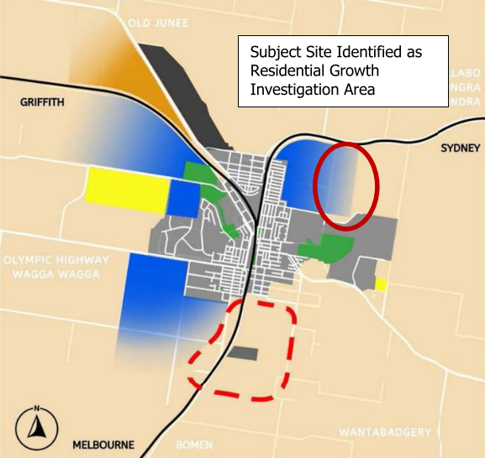

Figure 1: Junee LSPS 2040 - Subject Site Indicated

**Junee Local Environmental Plan 2012**

The planning proposal seeks to amend the current zoning and minimum lot size maps of the Junee LEP 2012. The current zoning and minimum lot size maps identify the site as being zoned RU1 Primary Production with a minimum lot size of 100ha. The proposed amended zoning map is shown below, including RU5 Village and R5 Large Lot Residential zones.

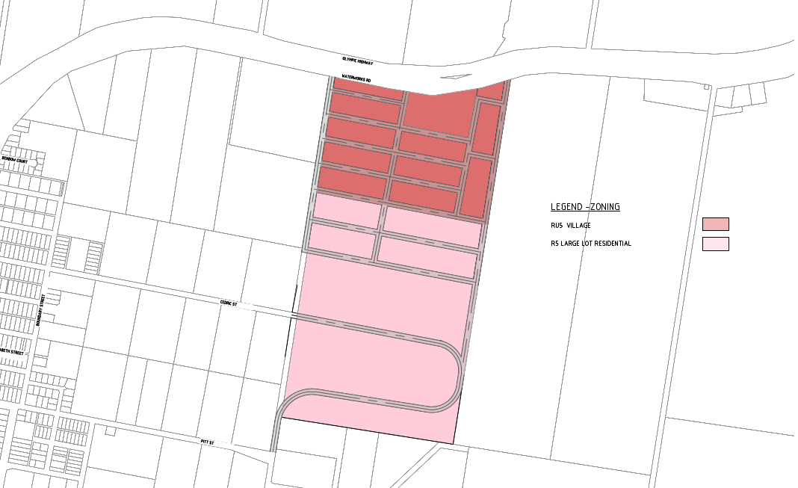

**Figure 2**: Proposed Zoning Map

In addition to the zoning changes, and in order to facilitate the types of development ordinarily permitted in those zones, it is also proposed to amend the minimum lot size of the site. The proposed minimum lot size mapping is shown below, including areas of 700sqm, 1500sqm and 4000sqm.

**Figure 3:** Proposed Minimum Lot Size Mapping

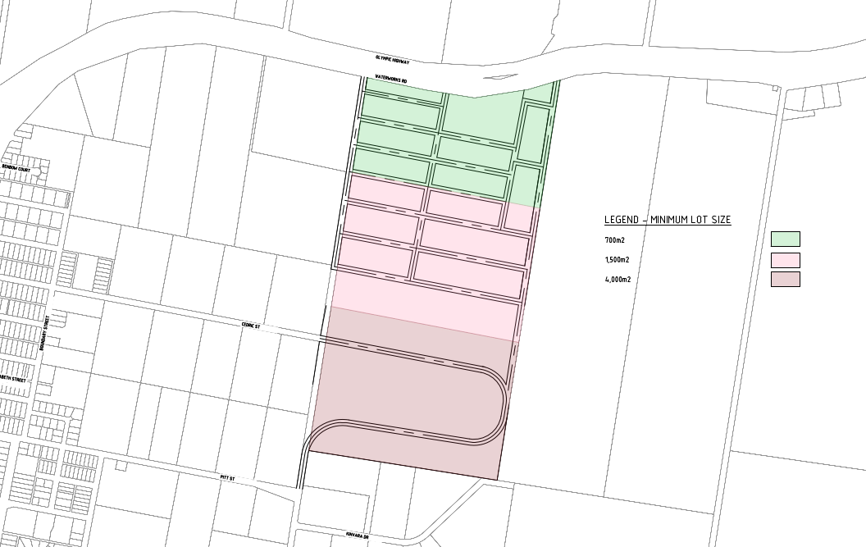

The subject land is not identified as being flood prone land, bushfire prone land or subject to any other overlay contained in the Junee LEP 2012 mapping, including biodiversity sensitivity, heritage items, salinity or riparian lands.

**Junee Development Control Plan 2021**

The planning proposal will not result in or require any immediate changes to the Junee Development Control Plan 2021.

**Risk Assessment**

The rezoning application does pose some ongoing risk to Council. The rezoning application will permit residential development on the site through further development applications, where it is anticipated that open space, road assets, stormwater and sewer infrastructure will be proposed. Council will need to be prepared to accept the ongoing management of these items as assets. There are no other significant risks to Council as a result of the planning proposal.

**Financial**

There is minimal financial risk to Council as a result of this planning proposal. Council has set fees in relation to the assessment of LEP Amendments, which have and will be applied throughout this process.

**CONCLUSION**

In conclusion, it is considered that Council can support the planning proposal including for the following reasons:

* + The proposal is consistent with the Junee LSPS 2040 and the identified Urban Growth Area Mapping for this part of Junee and has demonstrated adequate strategic merit.
  + The proposal meets the current demand for this type of land.
  + The subject land can be adequately serviced for the type of development that is likely to occur.
  + The proposal may support better stormwater management outcomes through the northeast of Junee.
  + The land is not subject to natural hazards mapping, potential contamination, or significant vegetation that would overly constrain development on this site.

The Planning Proposal is considered to be acceptable for presentation to the Department of Planning, Housing, and Infrastructure for Gateway Determination. This will permit further consultation and consideration of the Planning Proposal to occur. Council should also request to be made the local plan-making authority from the Department to amend the Junee Local Environmental Plan 2012 in relation to these proposed changes.